**DAILY ONLINE ACTIVITIES SUMMARY**

|  |  |  |  |  |  |  |  |
| --- | --- | --- | --- | --- | --- | --- | --- |
| **Date:** | **09/07/2020** | | | | **Name:** | **POOJA D S** | |
| **Sem & Sec** | **IV sem & B section** | | | | **USN:** | **4AL18CS056** | |
| **Online Test Summary** | | | | | | | |
| **Subject** | | **-** | | | | | |
| **Max. Marks** | | **30** | | **Score** | | **-** | |
| **Certification Course Summary** | | | | | | | |
| **Course** | **Predictive Modeling and Analytics** | | | | | | |
| **Certificate Provider** | | | **Greatlearning academy** | **Duration** | | | **5.5 hours** |
| **Coding Challenges** | | | | | | | |
| **Problem Statement1:------------------** | | | | | | | |
| **Status: -----------------** | | | | | | | |
| **Uploaded the report in Github** | | | | **-----------** | | | |
| **If yes Repository name** | | | | **-------------** | | | |
| **Uploaded the report in slack** | | | | **YES** | | | |

Online Test Summary: No internals conducted today.

Online Certification Course Summary: In today’s session I have learnt about the Multiple Linear Regression, Linear Regression Assumptions, Concept of Multicollinearity.

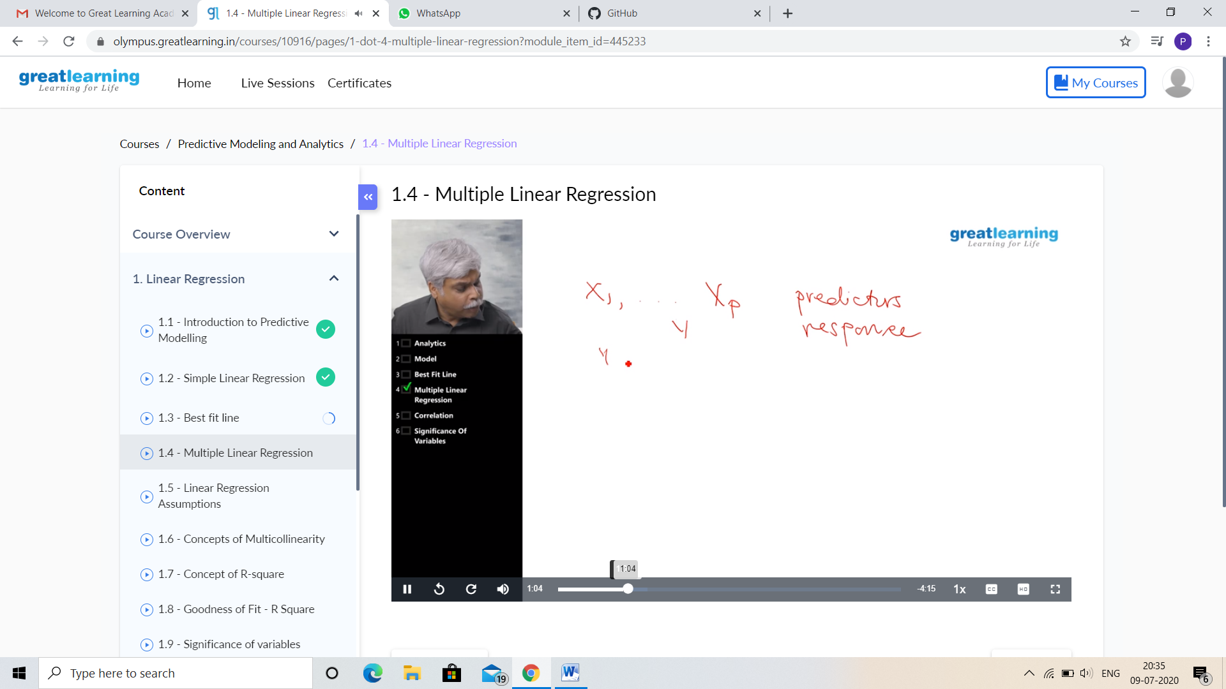

This is the snapshot of today’s session.

Online Coding Summary: No problem statements were given.

Online Training: Today I had attended the online training organized by CSE Department AIET. The training was on C++ programming language done by Prof. Shruthi Shetty J. CSE Dept. After the session the two programs were given to write.